**Assignment Week 12 – CE232 – Digital Systems**

**Instructions:**

1. **The students’ answers should be neatly written/typed**
2. **Submit the .pdf file to e-learning with file name: NIM(without zero)_Name_assignment1**
3. 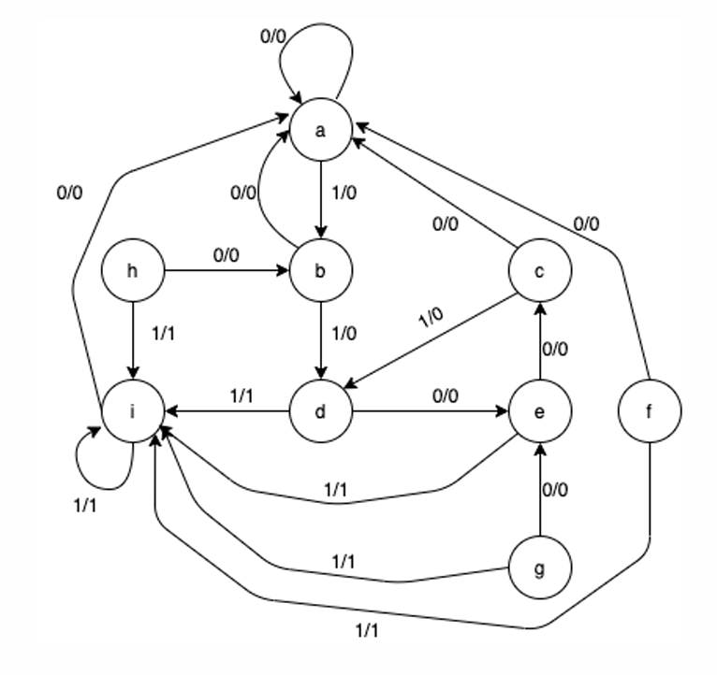Simplified the given state diagram. Show the reduced state table and the reduced state diagram.
4. Design a MOD-7 synchronous up-counter circuit using JK flip-flop. Create the state table for the circuit, the K-map, then draw the circuit.